### 

**Optics: Focal Lengths and Ray Diagrams**

**Pre-lab questions**

1. What is the goal of this experiment? What physics and general science concepts does this activity demonstrate to the student?
2. What is the thin lens approximation?
3. What is an expression of the thin lens equation?
4. What is an expression for the magnification ratio of a thin lens?
5. In a system of two thin lenses separated by a fixed distance *d*, what is the object distance to the second lens if the image distance from the first lens is *i*1?

The goal of this experiment is to help understand how an image is formed by a single thin lens, and how its focal length can be found by measuring the images formed. Using this information, how can we understand the image formed by a system of two thin lenses – making up an optical instrument.

# 

**Introduction**

Aswe frequently view it today, light is an electromagnetic phenomenon.It consists of electromagnetic waves propagating through a medium that is characterized by its refractive index. Geometrical optics, or ray optics, is a model for light that describes it in terms of rays traveling along straight-line directions and neglecting the effects of wave behavior. The ray in geometric optics is an abstraction useful for approximating the paths along which light propagates under certain circumstances. The approximation is good when the light wavelength is small compared to the size of objects with which the light interacts.

In geometrical optics, we assume that light rays

* propagate in straight-line paths as they travel in a uniform medium;
* bend (refract) at the boundary between two dissimilar media;
* may be absorbed or reflected.

When light enters a denser medium (as from air to glass), it slows down causing a change in its direction of travel (it refracts) in accord with Snell’s law of refraction. This phenomenon is used in the design of lenses that control the flow of light in useful ways, such as forming images of objects with the level of magnification desired. A lens can be characterized in several significant ways, including the refractive index, *n*, of the material it is made of (needed for use with Snell’s law) and its focal length, *f*. The focal length of a lens is the distance from the middle of the lens that an object ‘infinitely’ far away will form a clear image.

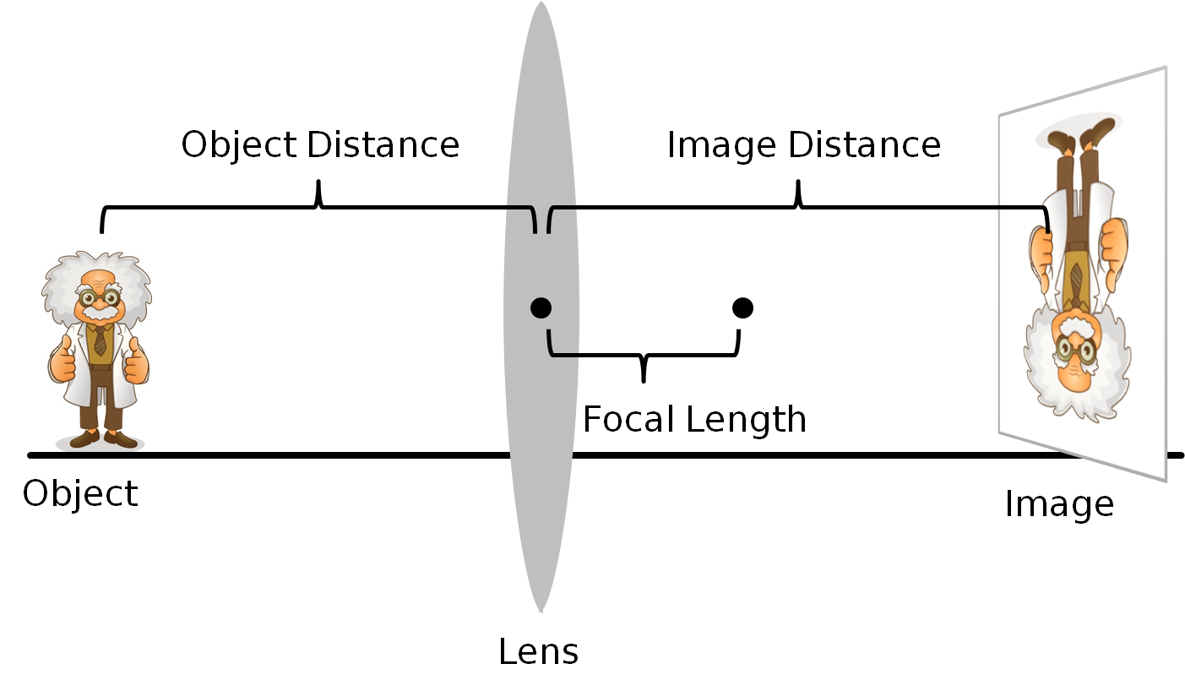In the thin lens approximation, the physical thickness of the lens is sufficiently small compared to the relevant optical character of the lens (its focal length) that the thickness of the lens can be ignored in defining the object and image distances with respect to the lens. Additionally, the paraxial (or small angle) approximation is used in geometrical optics for ray tracing. A paraxial ray makes a small angle (*θ*) with respect to the optical axis of the system and lies close to the axis. This allows three important approximations (for *θ* in radians) for calculation of the ray's path: .sin ⁡ θ ≈ θ , tan ⁡ θ ≈ θ and cos ⁡ θ ≈ 1. {\displaystyle \sin \theta \approx \theta ,\quad \tan \theta \approx \theta \quad {\text{and}}\quad \cos \theta \approx 1.}

Figure 1: Image formation by a convex thin lens.

Labeling the object distance as *do* and the image distance as *di*, a thin lens of focal length *f* follows the thin lens equation: $\frac{1}{d_{o}}+\frac{1}{d_{i}}=\frac{1}{f}$.

Convex lenses are called converging lenses; they have a positive focal length *f* > 0. Parallel rays of light converge in one point (called a focal point) when passing through the lens.

The image from a convex lens can be either real (on the opposite side of the lens as the object with *di* > 0) or virtual (on the same side of the lens as the object, with *di* < 0). Real images are inverted - upside-down. Virtual images are right-side up. The magnification ratio for a thin lens’ image, $M=\frac{image height}{object height}=-\frac{d_{i}}{d_{o}}$, will also show the image’s orientation. A real image has *M* < 0 indicating it is inverted, while a virtual image has *M* > 0 and it is upright.

The image is real when the object is farther out then the focal length. The image is virtual when the object is closer to the lens than the focal length.

Extending these ideas to an optical system consisting of several thin lenses is straightforward. For every pair of adjacent lenses along the optical path of the system, the object distance for the second lens is the difference between the spacing between the lenses and the image distance from the first lens. If *d* is the distance between the pair of adjacent lenses with *di*1 being the distance from the first lens to the image it has formed, then the object distance to the second lens is *do*2 = *d* – *di*1. The overall magnification, *M*, of the two-lens system is the product of the individual magnifications of each lens: $M=M_{1}M_{2}=\left[{-d_{i1}}/{d_{o1}}\right]∙\left[{{-d}_{i2}}/{d_{o2}}\right]$.

A *refracting telescope* uses lenses and the principle is very simple: the objective lens produces a first real image of a very far away object. From the thin lens equation, notice that if the distance to the object is very large ($d_{o}→∞$), then, $1/f=\left(1/{d_{o}}\right)+\left(1/{d_{i}}\right)≈1/{d_{i}}$ and the image forms coincident with the objective’s focal point. The eyepiece then is placed close to that first image, so that the first image falls within the eyepiece’s focal length and is thus magnified. The closer the first image is to the eyepiece’s focal point, the longer the distance to the final image. Astronomical telescopes are usually built so that the first image forms exactly at the focal point of the eyepiece lens. In this case, the separation between the lenses is exactly $d=f_{1}+f_{2}$, which is the length of the telescope tube.



Figure 2: Upper – First image formed of the object (at infinity) by the objective lens; Lower – Final, greatly magnified (virtual) image formed by the eyepiece lens.

In this experiment you will examine different kinds of lenses and how they affect the image when light is passing through it. We will use the thin lens equation and geometric optics to describe our observations.

**Equipment:** Basic Optics Light Source, Dynamics Track, Basic Optics Viewing Screen, (2) Convex lenses, (4) Optics Carriages, (2) Lens Holders, Ruler, Grid (printed)

**Experiment, Part A**

The purpose of this experiment is to determine the relationship between object distance and image distance for a thin convex lens, determine the lens’ focal length, and to measure the image magnification for the various object and image distances. You will determine the focal length by measuring several pairs of object and image distances and plotting 1/*do* versus 1/*di*.

Figure 3: Setup for Experiment A - Single thin lens

Figure 3: Experiment A setup.

1 m

Screen

Light source

Lens

**Procedure A**

1. Place the light source and the screen on the dynamics track 1 m apart with the light source’s crossed-arrow object toward the screen, as shown in Fig. 3. Place the lens between them. (Use the thicker of the two lenses.)
2. Starting with the lens close to the screen, slide the lens away from the screen to a position where a clear image of the crossed-arrow object is formed on the screen. Measure the image distance and the object distance. Record these measurements (and all measurements from the following steps) in Table 1.
3. Measure the object size and the image size for this position of the lens.
4. Without moving the screen or the light source, move the lens to a second position where the image is in focus. Measure the image distance and the object distance.
5. Measure the object size and image size for this position also. Note that you will not see the entire crossed-arrow pattern. Instead, measure the image and object sizes as the distance between two index marks on the pattern (see Figure 4 for example).



1. Repeat steps 2 and 4 with light source-to-screen distances of 90 cm, 80 cm, 70 cm, 60 cm, and 50 cm. For each light source-to-screen distance, find *two* lens positions where clear images are formed. (You don’t need to measure image and object sizes.).

Figure 4: Measure object or image size between two pattern features

**Table 1:**

|  |  |  |  |  |  |  |
| --- | --- | --- | --- | --- | --- | --- |
| **Distance from light source to screen** | *do* | *di* | 1/ *do* | 1/ *di* | **Image Size** | **Object Size** |
| 100 cm |  |  |  |  |  |  |
|  |  |  |  |  |  |
| 90 cm |  |  |  |  |  | |
|  |  |  |  |
| 80 cm |  |  |  |  |
|  |  |  |  |
| 70 cm |  |  |  |  |
|  |  |  |  |
| 60 cm |  |  |  |  |
|  |  |  |  |
| 50 cm |  |  |  |  |
|  |  |  |  |

**Analysis A1: Focal length**

1. Calculate 1/*do* and 1/*di* for all 12 rows in Table 1.
2. Plot 1/ *do* versus 1/ *di* and find the best-fit line (linear fit). This will give a straight line with the x- and y-intercepts equal to 1/*f*. Record the intercepts (including units) here:  
     
   y-intercept = 1/*f =*   
     
   x-intercept = 1/*f =*
3. For each intercept, calculate a value of *f* and record it in Table 2.
4. Find the percent difference between these two values of *f* and record them in Table 2.

(*Note: You can plot the data and find the best-fit line on paper or on a computer*)

**Table 2: Focal length**

|  |  |
| --- | --- |
|  | *f* |
| Result from x-intercept |  |
| Result from y-intercept |  |
| % difference between results from intercepts |  |
| Average of results from intercepts |  |

**Analysis A2: Magnification**

1. For the first two data points only (the first two lines of Table 1), use the image and object distances to calculate the magnification, *M*, at each position of the lens. Record the results in Table 3. (Recall that $M=-{d_{i}}/{d_{o}}$, with the appropriate sign conventions.)
2. Calculate the absolute value of *M* (for each of the two lens positions) using your measurements of the image size and object size. Record the results in Table 3. (Use the definition of $M={\left(image size\right)}/{\left(object size\right)}$.)
3. Calculate the percent differences between the absolute values of *M* found using the two methods. Record the results in Table 3.

**Table 3: Magnification**

|  |  |  |
| --- | --- | --- |
|  | **Point 1** | **Point 2** |
| *M* **calculated from image and object distances** |  |  |
| *M* **calculated from image and object sizes** |  |  |
| **% difference** |  |  |

**Experiment, Part B**

In this part of the experiment the refractive telescope (2 thin lens) arrangement will be used to examine an object that is a finite distance from the lenses. It will no longer be assumed that $d_{o1}→∞$.

## Procedure B: The Astronomical Telescope - Looking at a Nearby Object

In this part of the experiment the telescope arrangement will be used to examine an object that is a finite distance from the lenses. It will no longer be assumed that.

1. Install the Light Source so that its front edge (the side with the crossed-arrows) is at the mark on the track. Turn the light source on.
2. Place the +200-mm lens about 70 cm away from the light source and place the viewing screen behind the lens, as illustrated in Fig. 5.  
     
   

Figure 5: Initial setup for Experiment B - Refracting telescope

1. Move the viewing screen forward or backward until a sharp image of the crossed-arrows is seen. This is the first image. Record the position of the objective and the first image in Data Table 4.
2. Write a description of this first image in Data Table 4: Is it inverted or upright? Is it enlarged or reduced? Is it real or virtual?
3. Install the +100 mm lens (the eyepiece) directly behind the viewing screen.
4. With your eye close to the +100-mm eyepiece, look through the lens as you move it back away from the viewing screen. Stop when you are comfortably seeing a sharp and enlarged image of the back of the viewing screen. (You are using this lens as you would a magnifier glass, so adjust forward-and-backward until you get the best possible view of a magnified screen holder.)



1. Remove the viewing screen but remember the location of the first image. It helps to mark the location with a piece of tape on the side of the track.
2. Tape a copy of the grid (see the last page) onto the viewing screen.
3. Replace the light source with the viewing screen. The first image is now an image of the grid.



1. *Check for and Eliminate the Parallax. Parallax* is an apparent shifting of the image with respect to the background due to the motion of the observer. It happens when the image is not in the same plane as the object (grid pattern).

Check to see if your image shows parallax:

|  |  |
| --- | --- |
| * Open both eyes and look through the lens at the image with one eye while looking ‘around the edge’ of the lens at the grid pattern with the other eye. You should see the image-grid on top on a dimmer, smaller grid, as illustrated. * You may also see that the lines tend to curve near the edges of the lens, which is not shown in the illustrations. * Move your head up and down or side to side and observe how (or if) the image moves with respect to the grid. |  |

|  |  |  |
| --- | --- | --- |
| *Parallax —* the image appears to freely float in all directions above the actual grid. | | |
| *If there is parallax*, the image-grid will change position with respect to the smaller grid as you move your head. |  |  |
|  | (a) The view with both eyes open. | (b) Move your head and the image displaces with respect to the grid. |

|  |  |  |
| --- | --- | --- |
| *NO parallax* — the relative position of the image and the grid stay fixed for any position of the observer. | | |
| *If there is NO parallax*, then as you move your head the position of the image with respect to the background will not change. They will appear to be stuck together. |  |  |
|  | (a) The view with both eyes open. | (b) The view from any position of your head is the same. |

1. If you found that your image shows parallax, move the eyepiece lens until the image lines do not shift relative to the object lines when you move your head.
2. At this point record the position of the eyepiece in Data Table 4.

|  |  |
| --- | --- |
| 1. Visually estimate the total magnification of this telescope by counting the number of squares in the grid pattern that lie inside of one square of the image. Record the estimate in the data page. |  |

## Analysis B

1. Use the recorded positions to determine the following distances:

* Distance from object to objective lens,.
* Distance from objective lens to the first image,.
* Distance from the first image to the eyepiece lens,.

1. Use the thin-lens formula (Eq. 1) to calculate the distance from the eyepiece to the final image,.
2. Calculate the magnification of the images,  and.
3. Calculate the total magnification of the telescope,.

**Data Table 4 - Procedure B**: The Astronomical Telescope: Looking at a Nearby Object

|  |  |  |  |
| --- | --- | --- | --- |
| *Summary of Positions:* | | | |
| *Visual Description of the First Image:* | |  | Orientation: ___________________  Magnification: _________________  Type: _________________ |
| *Summary of Distances:* |  | | |
| *Visual Estimate of the Total Magnification:* | | | |
| *Theoretical Total Magnification:* | | | |

GRID PATTERN

Copy and attach to the Viewing Screen

# 